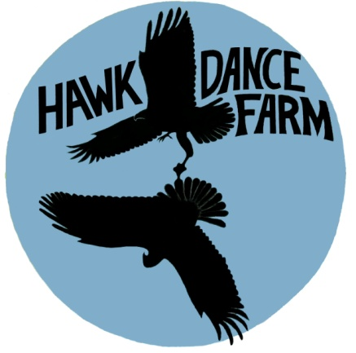

HAWK DANCE FARM CSA 2020 SEASON MEMBERSHIP FORM

FULL SHARE: $625.00 FOR 22 WEEKS MAY/JUNE – OCTOBER
(This is approximately $28.40 per week) Feeds 3-5 people

HALF SHARE: $325.00 FOR 22 WEEKS MAY/JUNE-OCTOBER
(This is approximately $14.77 per week) Feeds 1-2 people

WORK SHARES ARE AVAILABLE, INQUIRE FOR MORE DETAILS

PICK UP SITE:
AT THE COPAKE HILLSDALE FARMERS’ MARKETS ON SATURDAYS, 9am-1pm or if necessary, at the farm on Friday afternoon from 3-5pm or Saturday morning 9am-12pm
A payment in full with signed membership form is required.
HAWK DANCE FARM, 362 Rodman Road, Hillsdale, New York, 12529 518-325-1430 hawkdancefarm@yahoo.com

HAWK DANCE FARM 2020 PARTICIPATION AGREEMENT

I wish to support Hawk Dance Farm by becoming a member of their CSA.
I agree to collect my share of the harvest each week within the scheduled time frame. If there is an unforeseeable reason that I cannot come and pick up my share I can: send someone else in my place to collect my share during the scheduled pick up time or call and my share will be put into the cooler for me to pick up at the same time the next day at the farm. (If we do not get a phone call then your share that week is donated to a food pantry)
Your share will be available starting in May or June. A week before pick up begins; members receive an email to announce the starting date.
As a share member I am providing Hawk Dance Farm with the critical funds needed to operate the farm during the 2020 growing season. I agree to share in the risks of agriculture with the farmers, and I understand that although the farmers will aim to supply me with an ample supply of vegetables, there is no guarantee that any specific vegetable, or quantity, will be distributed in the share. I will share both the rewards and the risks of the growing season along with the other members and the growers.
The CSA harvest is protected by sustainable and organic practices such as organic soil care, crop rotation, and irrigation.
I understand that I am making a commitment to Hawk Dance Farm.

All memberships are accepted on a first come first serve basis. We have a limited number of share memberships available for the 2020 season. Please let us know which share you are requesting and where you would like to pick up.
NAME:
ADDRESS:
PHONE:
EMAIL:
SIGNATURE:

